Cross validation is a technique in machine learning used to avoid overfitting
HOW IT AVOIDS OVERFITTING
By splitting the data set into train and test, the model validation happens with some part of data. In train test split we will take first 800 records for train and last 200 for test out of 1000 records OR first 200 part for test and last 800 parts for train OR middle of the data part will be taken for test and other remaining parts for train.
The accuracy rate for all this different cross validations will be vary, all the varied accuracy will be summed to get average. This the process done in cross validation
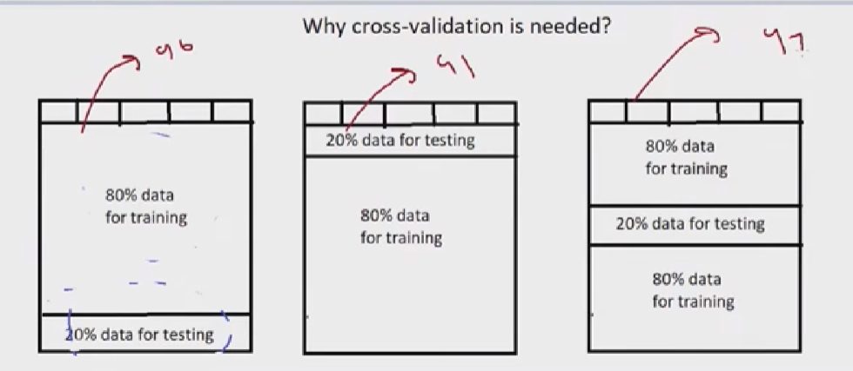
TYPES OF CROSS VALIDATIONS
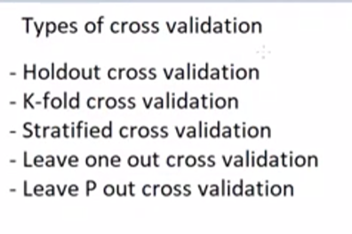
Holdout is splitting the data to 80,20 ratio.
In kfold all the red box will be the validation data. Validation error for each fold will be added to find the average
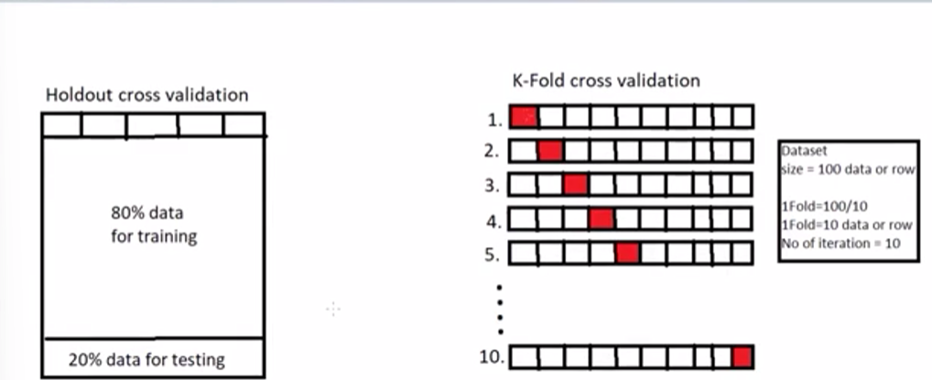
Stratified K Fold cross validation
